**Practical File**



**Operating Systems (MCA-163)**

Submitted by: Submitted to:

Name: Abhishek Tyagi Name: Mr. Alok Mishra

Roll no: 03311104422 Asst. Professor

Sem: MCA 1st

**Index**

|  |  |
| --- | --- |
| **Practical No** | **Practical Name** |
| 1 | Q 1 Write the linux command to display the calendar with various options. |
| 2 | Q 2 Write a linux command to display date with various options. |
| 3 | Q 3 Write a linux command to display the list of users who are currently using linux server. |
| 4 | Q 4 Write a linux command to display your system details. |
| 5 | Q 5 Write a linux command to create text file |
| 6 | Q 6 Write linux command to list all the directories and files on the server. |
| 7 | Q 7 Write the linux command to display the content of a file. |
| 8 | Q 8 Write the linux command to print the content on standard output device. |
| 9 | Q 9 Write the linux command to perform calculations. |
| 10 | Q 10 Write the linux command to show the current working directory. |
| 11 | Qs 11 Write the Linux command to get help with various options. |
| 12 | Q 12 Write the linux command to display what all users are currently doing. |
| 13 | Q 13 Write the linux command to create a directory. |
| 14 | Q 14 Write the linux command to change the directory. |
| 15 | Q 15 Write the linux command to remove a directory. |
| 16 | Q 16 Write the linux command to delete a file. |
| 17 | Q 17 Write the linux Command to copy a file to some other location. |
| 18 | Q 18 Write the linux command to move a file to some different location. |
| 19 | Q 19 Write the linux command to count the number of words, lines and sentences in the file |
| 20 | Q 20 Write the linux command to give the alias name. |
| 21 | Q 21 Write the linux command to view the exiting aliases. |
| 22 | Q 22 Write the linux command to unalias the exiting alias name. |
| 23 | Q 23 Write the linux command to display the hostname of the system. |
| 24 | Qs 24 Write the linux command to get information about the operating System. |
| 25 | Q 25 Write the linux command to view first 5 lines of a file. |
| 26 | Q 26 Write the linux command to view last 20 lines of a file. |
| 27 | Q 27 Write the linux command to view last 2 lines of a file. |
| 28 | Q 28 Write the linux command to check the default permission of a file |
| 29 | Q 29 Write the linux command to show the use of Basic Regular Expressions using grep Command. |
| 30 | Q 30 Write the Linux command to display detailed information about processes. |
| 31 | Q 31. PROGRAM FOR SYSTEM CALLS OF UNIX OPERATING SYSTEMS (OPENDIR, READDIR, CLOSEDIR) |
| 32 | PROGRAM FOR SYSTEM CALLS OF UNIX OPERATING SYSTEM (fork, getpid, exit) |
| 33 | Write an appropriate „C‟ program which implements the concept of dynamic memory allocation (use of malloc(), calloc(), realloc(), and free() system call. |
| 34 | Write an appropriate „C‟ program which implements the concept of fork() system call. |
| 35 | . Write an appropriate „C‟ program which implements the concept of exit() system  call |

**Q 1 Write the linux command to display the calendar with various**

**options.**

Command: Calendar

Syntax: cal

Description: This command displays the calendar on the screen. Options:

Cal -3

Description: This command displays three months –previous,current and next

Cal –s

Description: This command displays the month with first day as Sunday Cal-m

Description: This command displays the month with first day as Monday cal year

Description: This command displays calendar of whole year

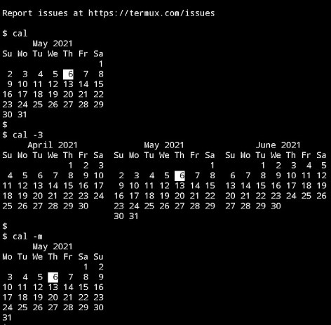

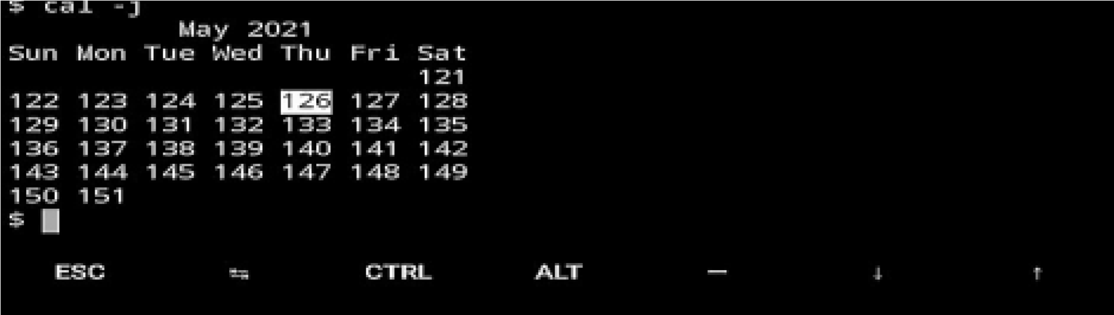

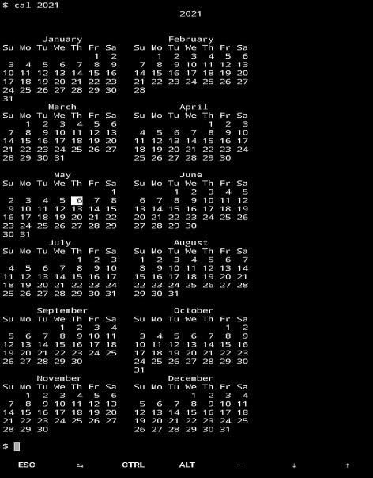

**Q 2 Write a linux command to display date with various options. Syntax: date**

Description : This command displays the current date on the screen. Options:

Date --date=”next mon”

Description :This command displays the date on next Monday.

Date --date=”1 day ago”

Description: This command displays the previous date of 1 day ago.

Date --date”10 day ago”

Description: This command displays the previous date of 10 days ago. Date +%y

Description: This command displays the last 2 digits of current year.

Date +%Y

Description: This command displays the current year.

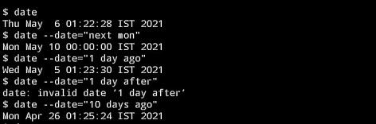

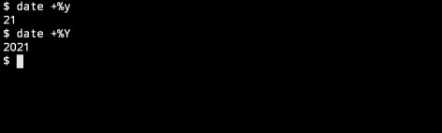

**Q 3 Write a linux command to display the list of users who are currently using linux server.**

Command: Who

Syntax: who

Description: This command displays the number of users currently working on the server. Options who -a who –d who –H

who –b

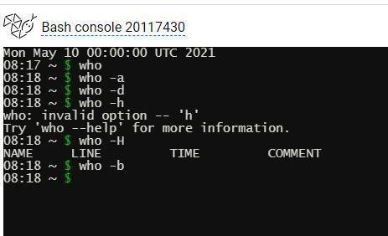

**Q 4 Write a linux command to display your system details.**

**Command: lscpu**

Syntax: lscpu

Description: This command displays details of operating system.

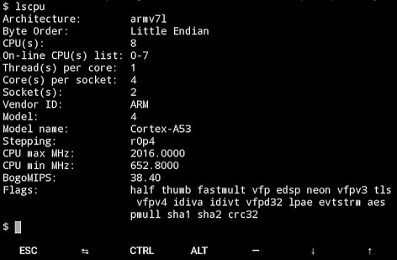

**Q 5 Write a linux command to create text file**

Command: touch ,cat Syntax: touch t2.txt

cat > t3.txt

Description : This command will create text file in linux

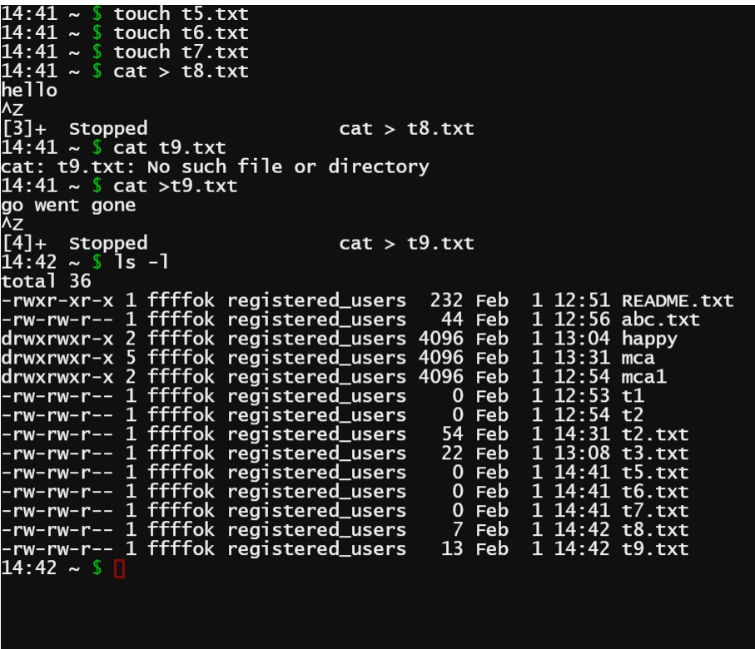

**Q 6 Write linux command to list all the directories and files on the server.**

Command: List

Syntax: ls

Description: This command displays the list of all directories and files in a particular directory.

Options:

ls –i ls –l ls –a

ls-b

Ls-d

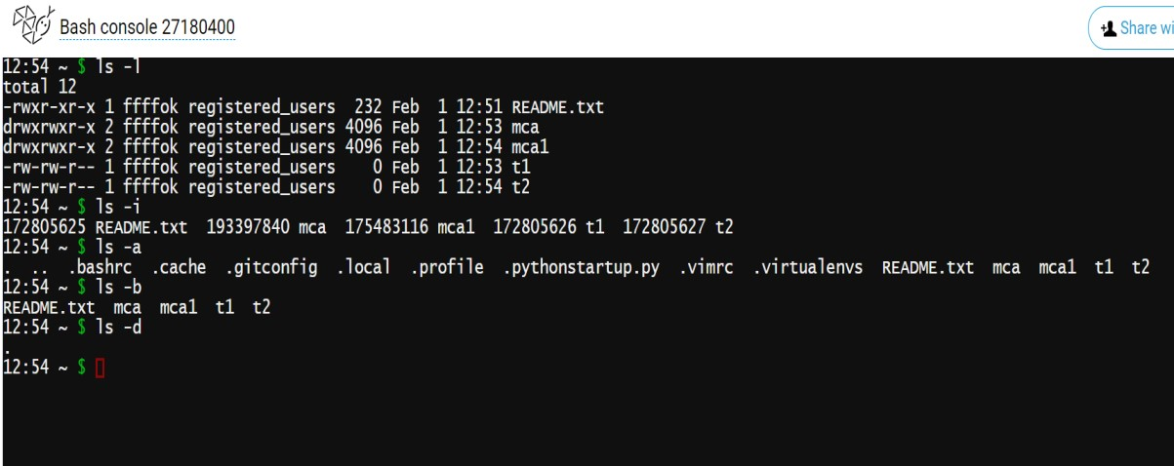

**Q 7 Write the linux command to display the content of a file.**

Command: Cat

Syntax: cat

Description: This command displays the list of all directories and files in a particular directory.

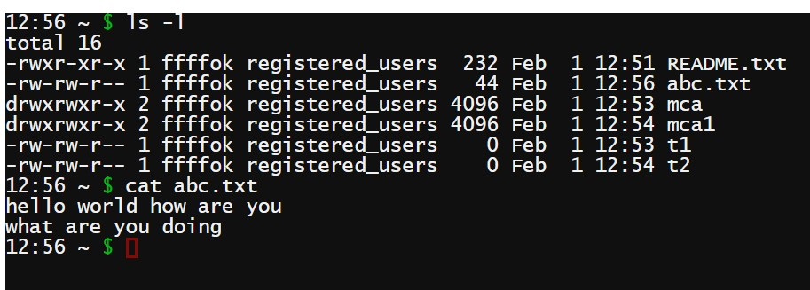

**Q 8 Write the linux command to print the content on standard output device.**

Command: Echo

Syntax: echo

Description: This command prints the content on standard output device.

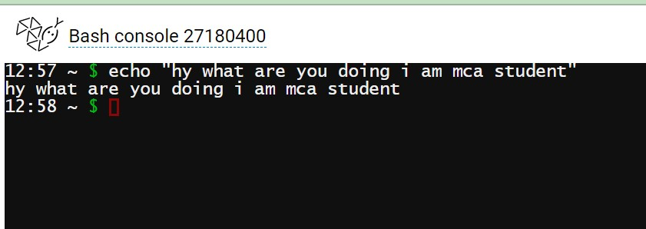

**Q 9 Write the linux command to perform calculations.**

Command: Basic Calculator

Syntax: bc

Description: This command performs the basic calculations.

Options:

bc-i bc-h bc-l bc-v bc-s

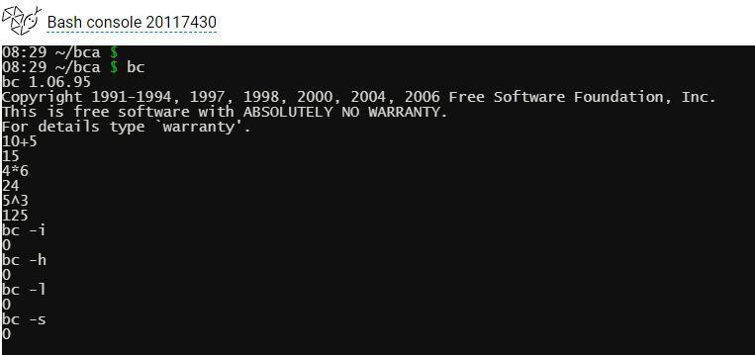

**Q 10 Write the linux command to show the current working directory.**

Command: Working Directory

Syntax: pwd

Description: This command displays the current working directory .

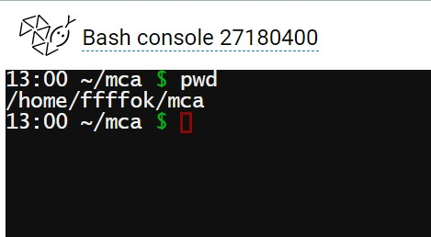

**Qs 11** **Write the Linux command to get help with various options. Command :-**

⮚ Ls --help : List help page of ls command with their option.

⮚ Cat --help : Lists help page of cat command with their option.

⮚ cp --help : Lists help page of cp command with their option.

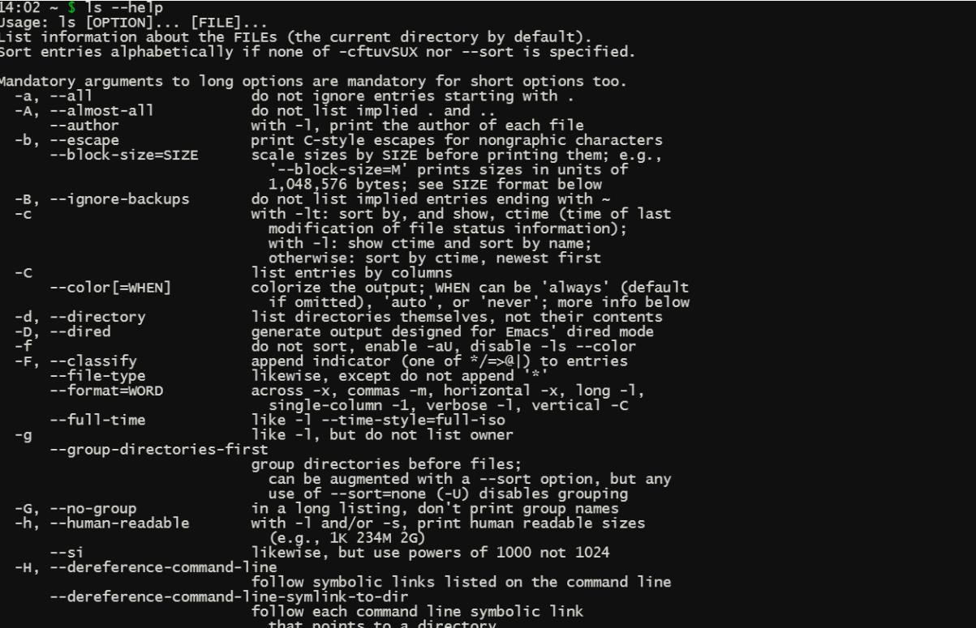

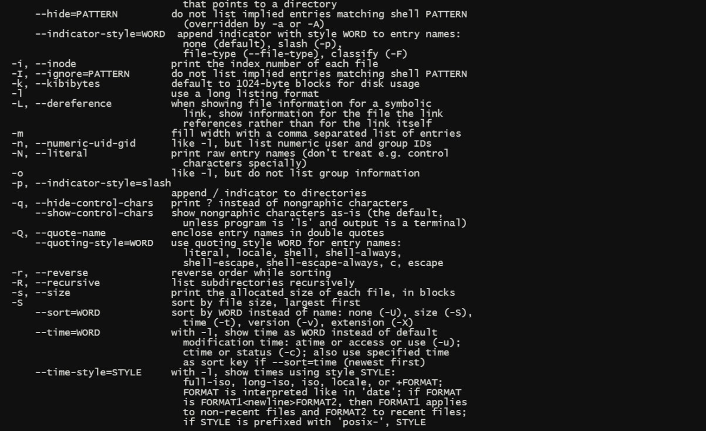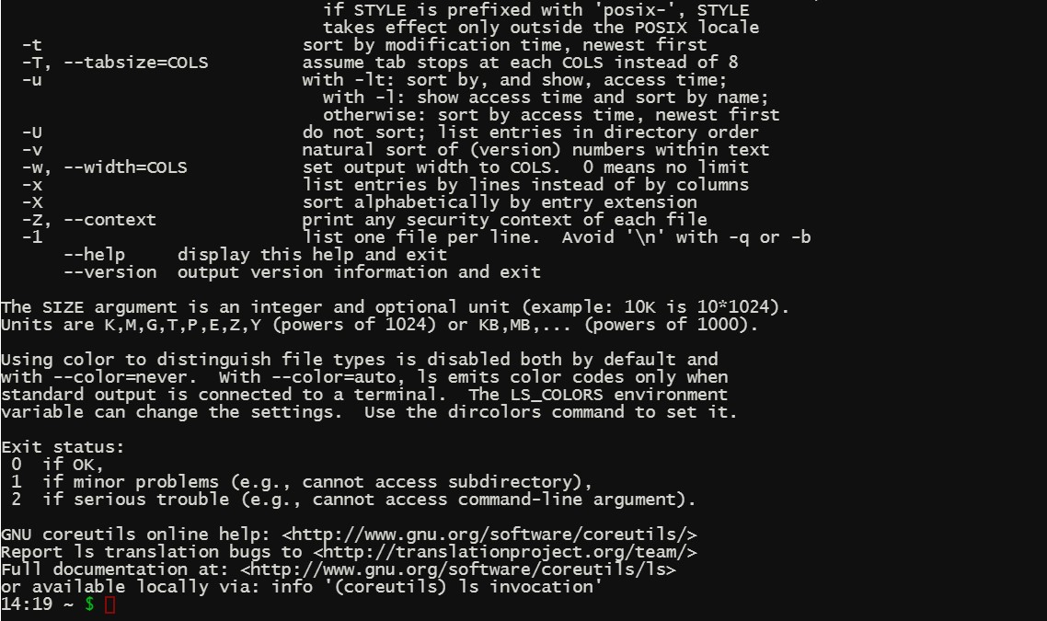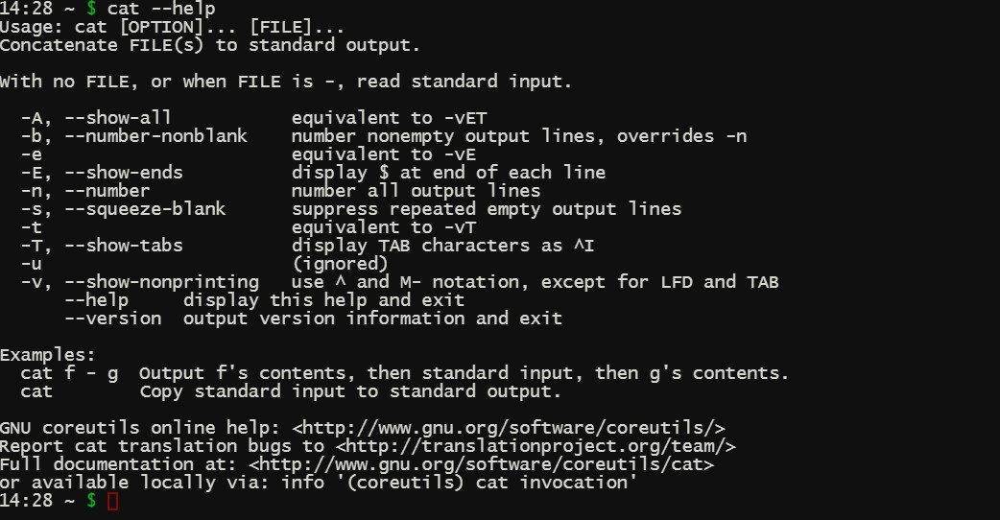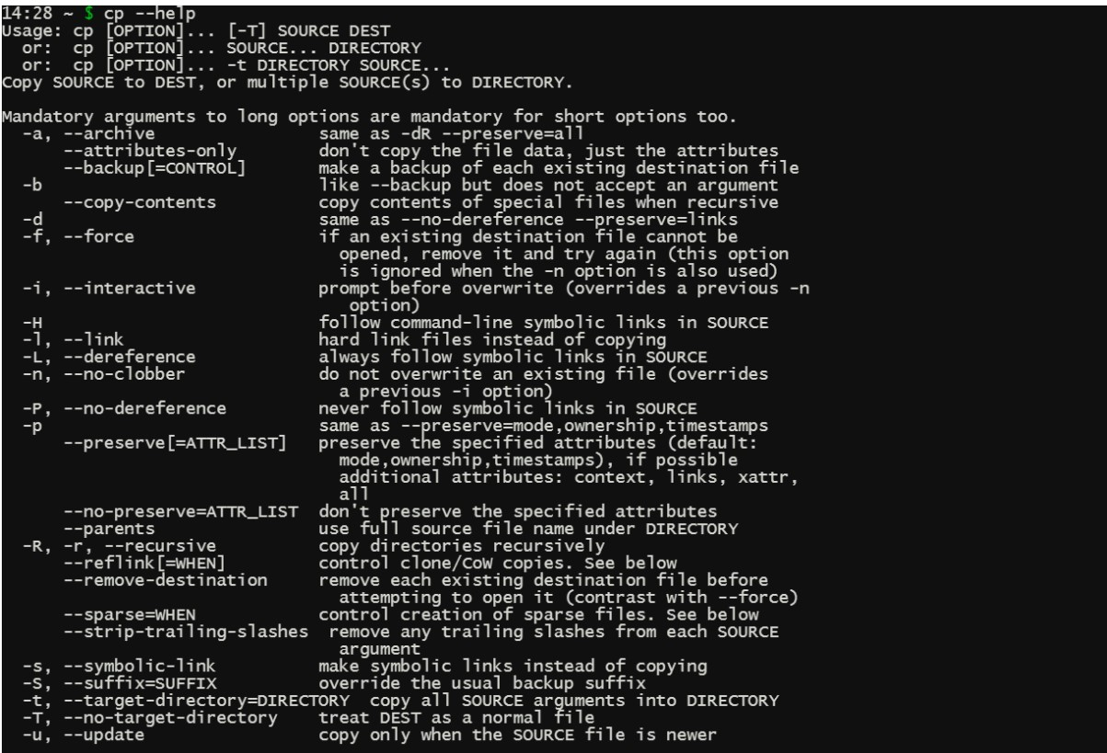

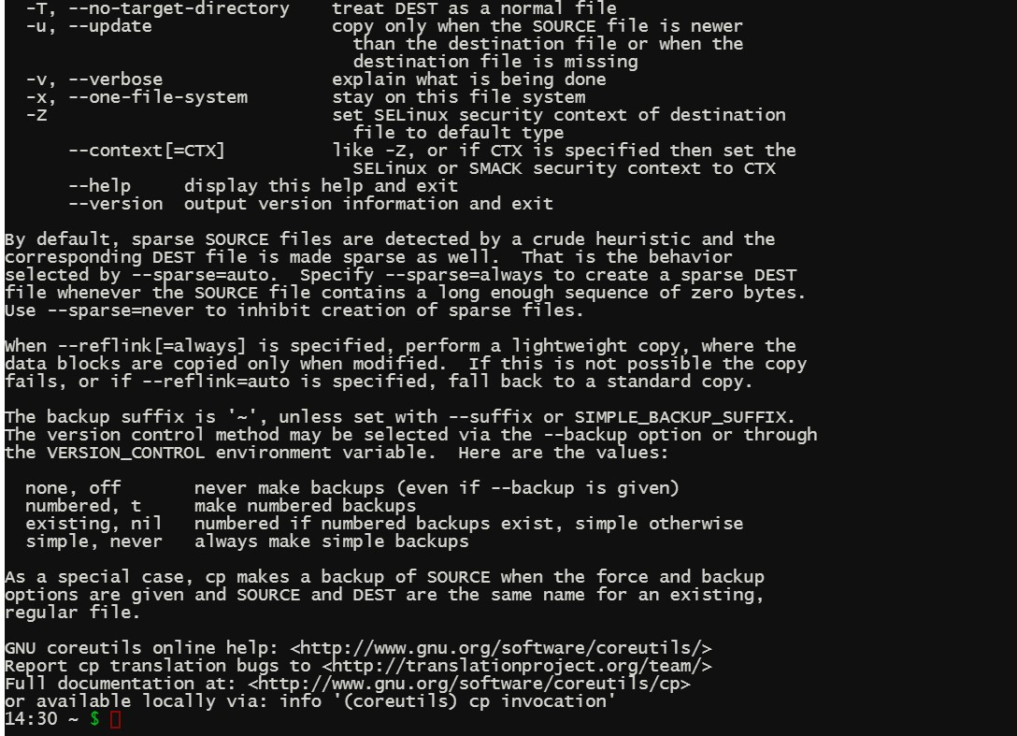

**Q 12 Write the linux command to display what all users are currently doing.**

Command: w

Syntax: w

Description: This command displays what all users are currently doing. Options w-s W –h w-u W-f

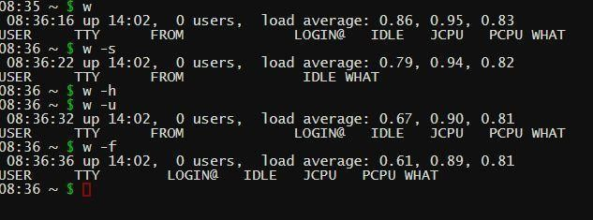

**Q 13 Write the linux command to create a directory.**

Command: Make directory

Syntax: mkdir

Description: This command creates a directory.

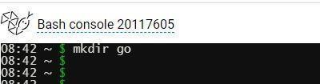

**Q 14 Write the linux command to change the directory.**

Command: Change directory

Syntax: cd

Description: This command changes the directory.

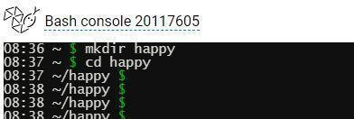

**Q 15 Write the linux command to remove a directory.**

Command: Remove directory

Syntax: rmdir

Description : This command removes a directory.

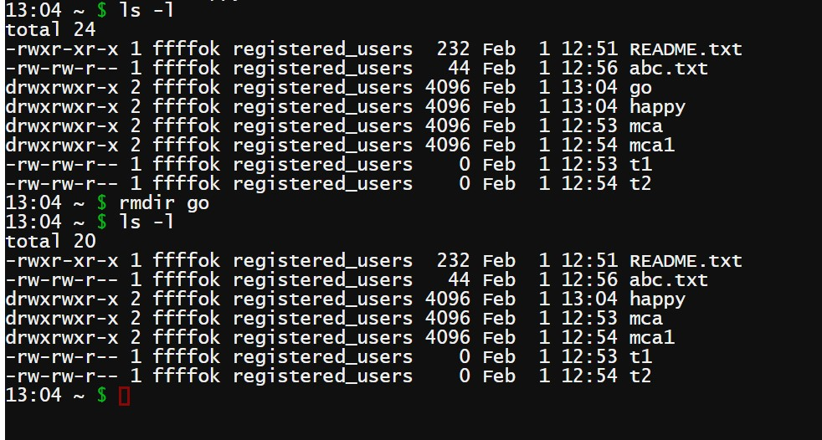

**Q 16 Write the linux command to delete a file.**

Command: Remove file

Syntax: rm

Description : This command removes a file.

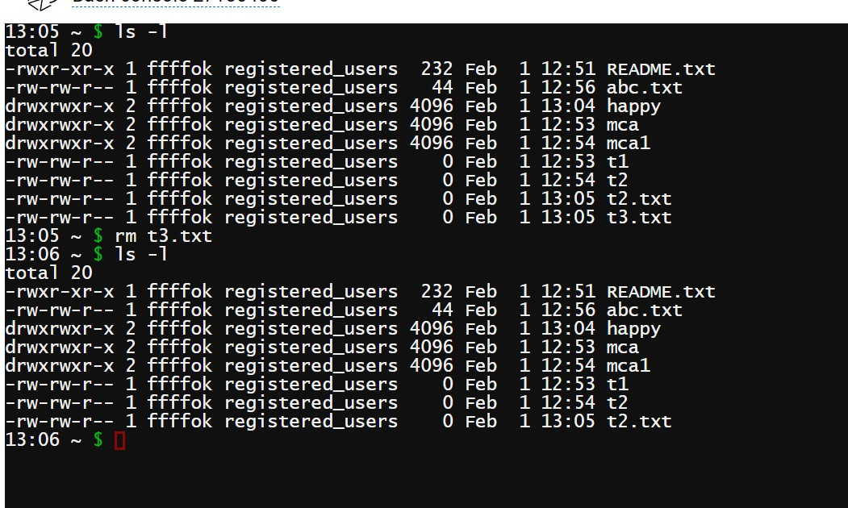

**Q 17 Write the linux Command to copy a file to some other location.**

Command: copy

Syntax: cp source_file destination_file

Description : This command copies a file to other location.

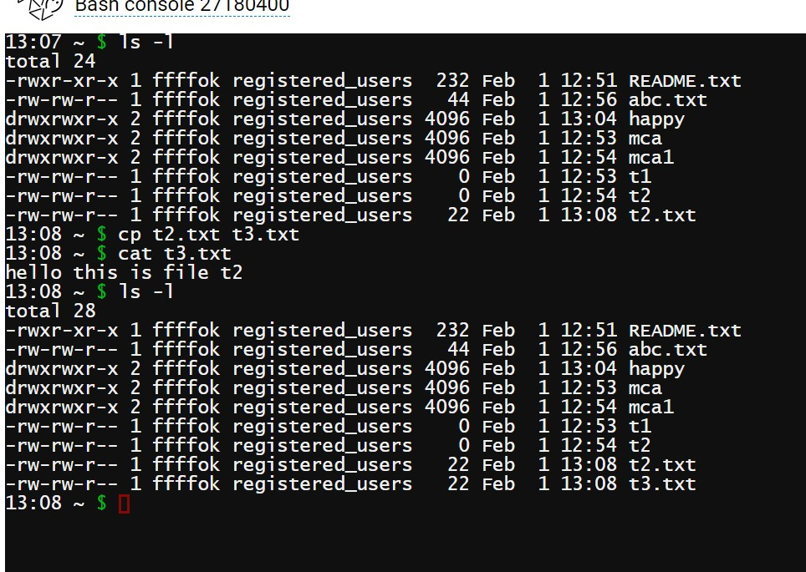

**Q 18 Write the linux command to move a file to some different location.**

Command: move

Syntax: mv source_file destination_file

Description : This command move a file to other location.

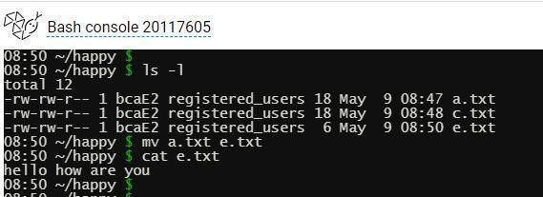

**Q 19 :Write the linux command to count the number of words, lines and sentences in the file**

Command: Word Count

Syntax: wc filename

Description : This command count the number of words, lines and sentences in the file Options

Wc –c

Wc –m

Wc –l

Wc –L

Wc –w

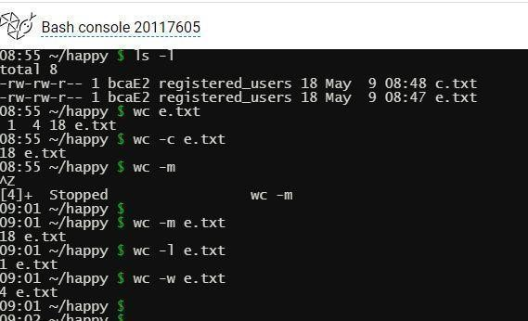

**Write the linux command to give the alias name.**

Command: alias

Syntax: alias alias_name=”command”

Description : This command gives alias to another commands

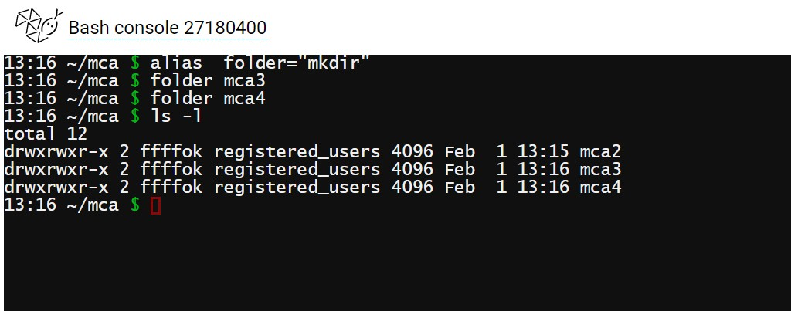

**Write the linux command to view the exiting aliases.**

Command: alias

Syntax: alias

Description : This command displays the existing aliases.

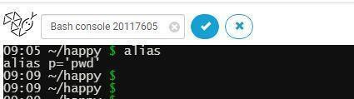

**Write the linux command to unalias the exiting alias name.**

Command: unalias

Syntax: unalias command_name

Description : This command removes the aliases.

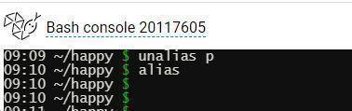

**Write the linux command to display the hostname of the system.**

Command: hostname

Syntax: hostname

Description : This command display the hostname of system.

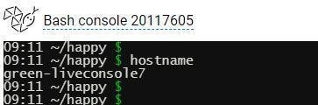

**Qs 24 Write the linux command to get information about the operating System.**

**Command :-**uname is used to give you information about your operating system. Uname is the short name for unix name.

⮚ Uname -s : To reveal the kernel name

⮚ Uname -r : Gives you details about kernel release youre using

⮚ Uname -v: Used to fetch the kernel version.

⮚ Uname -n: Parameter -n will give you the node hostname.

⮚ Uname -i: To show you hardware platform.

⮚ Uname -o: What operating system you are running

⮚ Uname -a: One parameter that can reveal all information

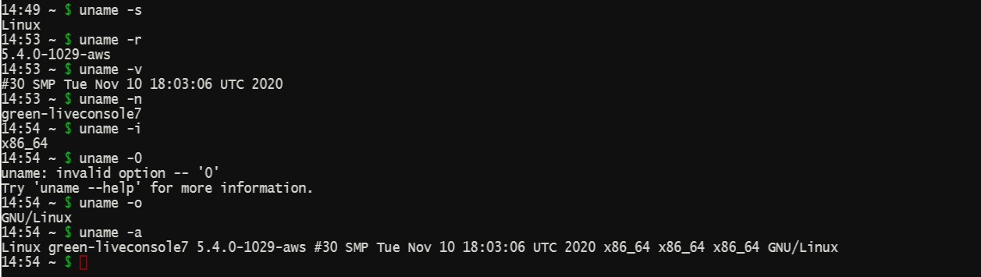

**Write the linux command to view first 5 lines of a file.**

Command: head

Syntax: head –5 filename

Description : This command display first 5 lines of a file.

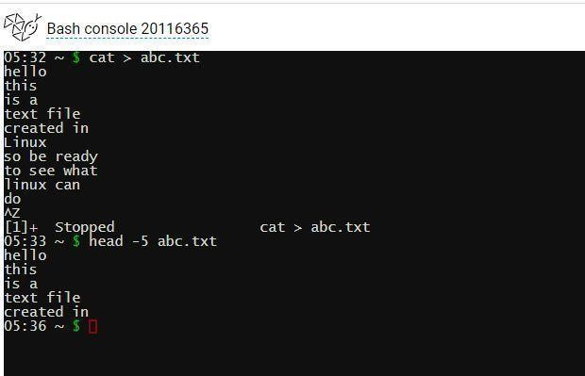

**Q 26 Write the linux command to view last 2 lines of a file.**

Command: tail

Syntax: tail -2 filename

Description : This command displays last 20 lines of a file.

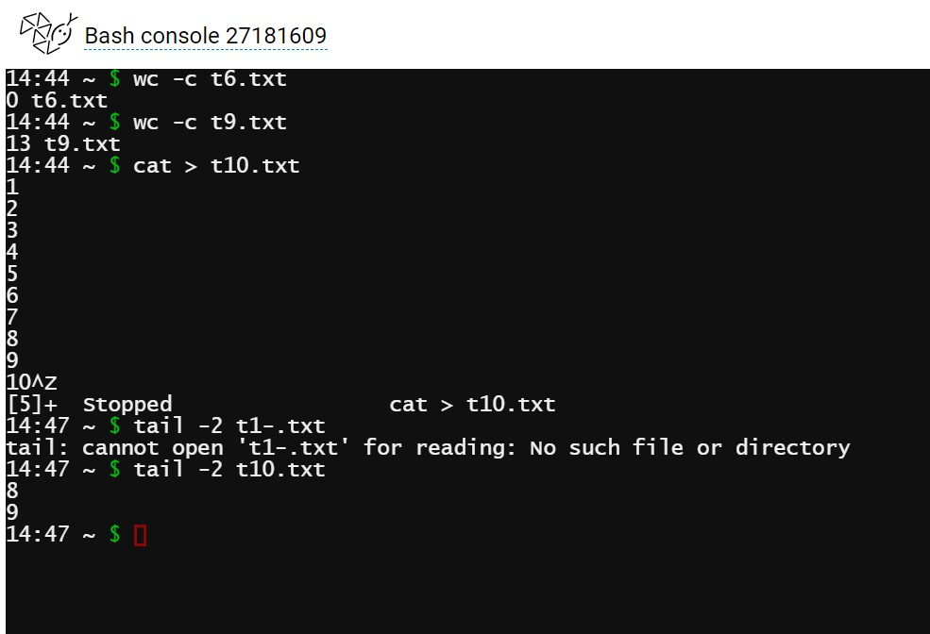

**Write the linux command to view last 20 lines of a file.**

Command: tail

Syntax: tail -20 filename

Description : This command displays last 20 lines of a file.

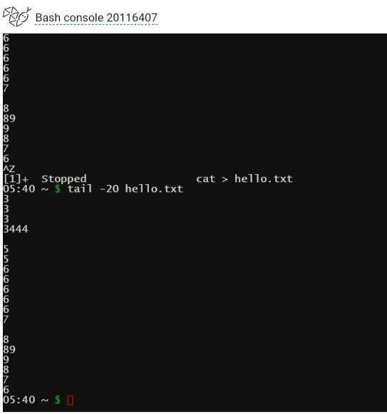

**Write the linux command to check the default permission of**

**a file**

Command: ls -l

Syntax: ls -l

Description : This command checks the default permission of a file

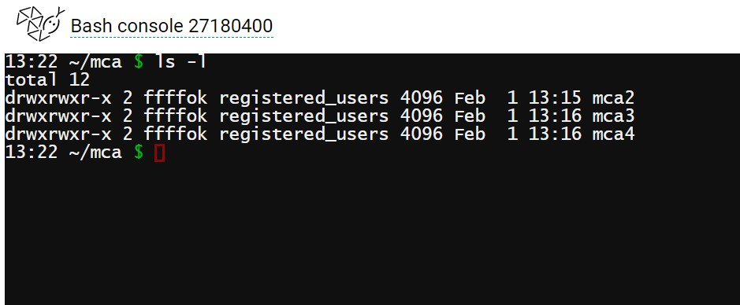

**Write the linux command to show the use of Basic Regular Expressions using grep Command.**

Command: grep

Syntax: grep “[aA]”

Description : This command searches for specific pattern in a file.

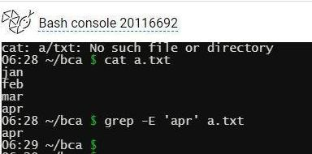

**Q 30 Write the Linux command to display detailed information about processes.**

Command: ps

**Syntax: ps [OPTIONS]**

**Description:** ps displays information about a selection of active processes. If you want a repetitive update of the selection and displayed information, use top(1) instead.

ps -f: Ps is used for process state. -f command is used to show full list ps -e: ps is used for process state. -e command is used to show process for your own system.

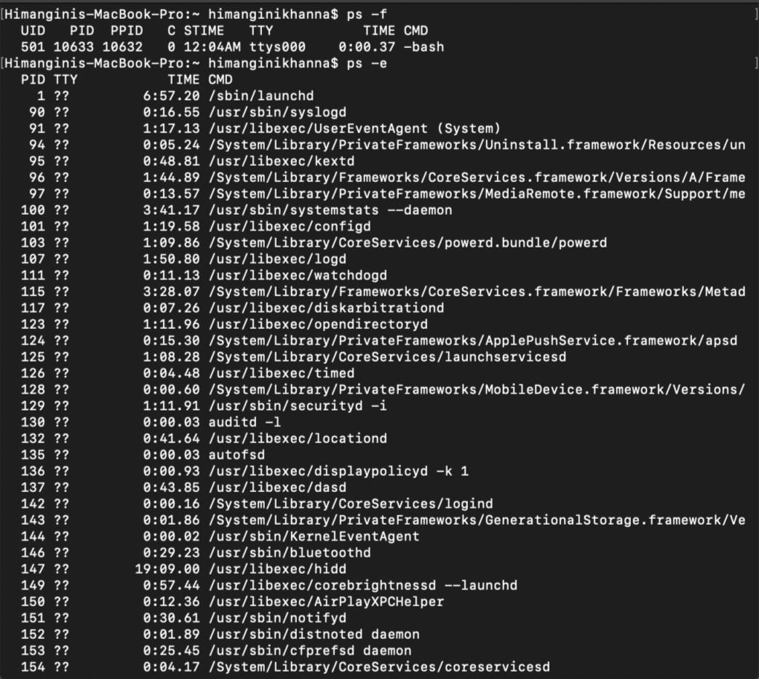

**31. PROGRAM FOR SYSTEM CALLS OF UNIX OPERATING SYSTEMS (OPENDIR, READDIR, CLOSEDIR) ALGORITHM:**

STEP 1: Start the program.

STEP 2: Create struct dirent.

STEP 3: declare the variable buff and pointer dptr.

STEP 4: Get the directory name.

STEP 5: Open the directory.

STEP 6: Read the contents in directory and print it.

STEP 7: Close the directory.

**PROGRAM:**

#include<stdio.h> #include<dirent.h> struct dirent *dptr; int main(int argc, char *argv[])

{ char buff[100]; DIR *dirp; printf(“\n\n ENTER DIRECTORY NAME”); scanf(“%s”, buff); if((dirp=opendir(buff))==NULL)

{ printf(“The given directory does not exist”); exit(1); }

while(dptr=readdir(dirp))

{ printf(“%s\n”,dptr->d_name);

} closedir(dirp);

}

**32. PROGRAM FOR SYSTEM CALLS OF UNIX OPERATING SYSTEM**

**(fork, getpid, exit)**

**ALGORITHM:**

STEP 1: Start the program.

STEP 2: Declare the variables pid,pid1,pid2.

STEP 3: Call fork() system call to create process.

STEP 4: If pid==-1, exit.

STEP 5: Ifpid!=-1 , get the process id using getpid().

STEP 6: Print the process id.

STEP 7:Stop the program

**PROGRAM:**

#include<stdio.h> **#include <unistd.h>** int main()

{

int pid,pid1,pid2;

pid=fork(); if(pid==-1)

{

printf(“ERROR IN PROCESS CREATION \n”); exit(1); } if(pid!=0)

{

pid1=getpid(); printf(“\n the parent process ID is %d\n”, pid1);

} else { pid2=getpid(); printf(“\n the child process ID is %d\n”, pid2);

} return 0;

}

33.  **Write an appropriate „C‟ program which implements the concept of dynamic memory allocation (use of malloc(), calloc(), realloc(), and free() system call.**

#include <stdio.h> #include <stdlib.h> int main()

{

int* ptr; int n, i; n = 5;

printf("Enter number of elements: %d\n", n); ptr = (int*)calloc(n, sizeof(int)); if (ptr == NULL) {

printf("Memory not allocated.\n");

exit(0);

}

else {

printf("Memory successfully allocated using calloc.\n"); for (i = 0; i < n; ++i) { ptr[i] = i + 1;

}

printf("The elements of the array are: "); for (i = 0; i < n; ++i) { printf("%d, ", ptr[i]);

}

n = 10;

printf("\n\nEnter the new size of the array: %d\n", n); ptr = realloc(ptr, n * sizeof(int));

printf("Memory successfully re-allocated using realloc.\n"); for (i = 5; i < n; ++i) { ptr[i] = i + 1;

}

printf("The elements of the array are: "); for (i = 0; i < n; ++i) { printf("%d, ", ptr[i]);

}

free(ptr);

}

return 0;

}

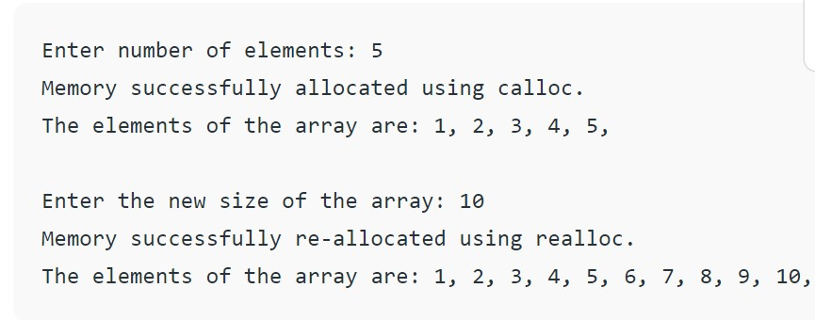

**34. Write an appropriate „C‟ program which implements the concept of fork() system call.** #include <stdio.h> #include <unistd.h> int main() {

int id;

printf("Hello, World!\n"); id = fork(); if (id > 0) {

printf("This is parent section [Process id: %d].\n", getpid());

}

else if (id == 0) {

printf("fork created [Process id: %d].\n", getpid()); printf("fork parent process id: %d.\n", getppid());

} else {

printf("fork creation failed!!!\n");

} return 0;

}

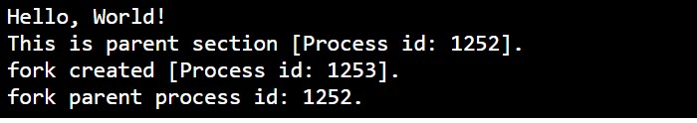

**35. Write an appropriate „C‟ program which implements the concept of exit() system call**

#include <stdlib.h> int main ()

{

// declaration of the variables int i, num; printf ( " Enter the last number: "); scanf ( " %d", &num); for ( i = 1; i<num; i++)

{

// use if statement to check the condition if ( i == 6 )

/* use exit () statement with passing 0 argument to show termination of the program without any error message. */ exit(0);

else

printf (" \n Number is %d", i);

} return 0;

}

